**Computer Network (Lab) 2020-21**

**Practice Assignment 4**

***Indicative Solution***

**Network Scenario:**

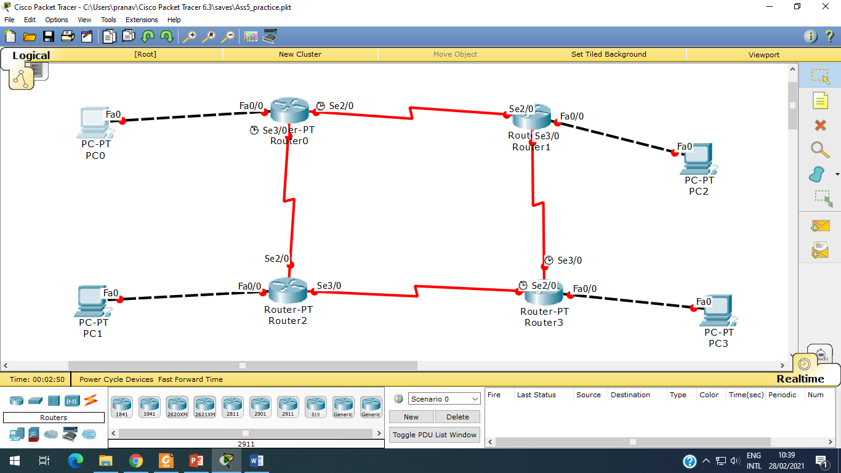

**Step 1:** Create a scenario in Packet tracer as per diagram.

**Step 2:** Set IP addresses to all PC (0-10)

|  |  |
| --- | --- |
| **PC0** | |
| IP Address | 192.168.0.2 |
| Subnet Mask | 255.255.255.0 |
| Default Gateway | 192.168.0.1 |
| **PC1** | |
| IP Address | 193.16.0.2 |
| Subnet Mask | 255.255.255.0 |
| Default Gateway | 193.16.0.1 |
| **PC2** |  |
| IP Address | 196.38.0.2 |
| Subnet Mask | 255.255.255.0 |
| Default Gateway | 193.38.0.1 |
| **PC3** |  |
| IP Address | 194.27.0.2 |
| Subnet Mask | 255.255.255.0 |
| Default Gateway | 194.27.0.1 |

**Step 3:** Configure Router 0 (from CLI prompt of Router 0)

Router>enable

Router#configure terminal

Enter configuration commands, one per line. End with CNTL/Z.

Router(config)#**interface FastEthernet0/0**

Router(config-if)#ip address 192.168.0.1 255.255.255.0

Router(config-if)#no shutdown

Router(config-if)#exit

Router(config)#**interface Serial2/0**

Router(config-if)#ip address 10.12.0.1 255.0.0.0

Router(config-if)#no shutdown

Router(config-if)#exit

Router(config)#**interface Serial3/0**

Router(config-if)#ip address 20.21.0.1 255.0.0.0

Router(config-if)#no shutdown

Router(config-if)#exit

Router(config)#exit

Router#

**Step 4:** Configure Router 1 (from CLI prompt of Router 1)

Router>enable

Router#configure terminal

Enter configuration commands, one per line. End with CNTL/Z.

Router(config)#**interface FastEthernet0/0**

Router(config-if)#ip address 196.38.0.1 255.255.255.0

Router(config-if)#no shutdown

Router(config-if)#exit

Router(config)#**interface Serial2/0**

Router(config-if)#ip address 10.12.0.2 255.0.0.0

Router(config-if)#no shutdown

Router(config-if)#exit

Router(config)#**interface Serial3/0**

Router(config-if)#ip address 190.16.0.2 255.255.0.0

Router(config-if)#no shutdown

Router(config-if)#exit

Router(config)#exit

Router#

**Step 5:** Configure Router 2 (from CLI prompt of Router 2)

Router>enable

Router#configure terminal

Enter configuration commands, one per line. End with CNTL/Z.

Router(config)#**interface FastEthernet0/0**

Router(config-if)#ip address 193.16.0.1 255.255.255.0

Router(config-if)#no shutdown

Router(config-if)#exit

Router(config)#**interface Serial2/0**

Router(config-if)#ip address 20.21.0.2 255.0.0.0

Router(config-if)#no shutdown

Router(config-if)#exit

Router(config)#**interface Serial3/0**

Router(config-if)#ip address 191.120.16.1 255.255.0.0

Router(config-if)#no shutdown

Router(config-if)#exit

Router(config)#exit

Router#

**Step 6:** Configure Router 3 (from CLI prompt of Router 3)

Router>enable

Router#configure terminal

Enter configuration commands, one per line. End with CNTL/Z.

Router(config)#**interface FastEthernet0/0**

Router(config-if)#ip address 194.27.0.1 255.255.255.0

Router(config-if)#no shutdown

Router(config-if)#exit

Router(config)#interface Serial2/0

Router(config-if)#ip address 191.120.16.2 255.255.0.0

Router(config-if)#no shutdown

Router(config-if)#exit

Router(config)#**interface Serial3/0**

Router(config-if)#ip address 190.16.0.1 255.255.0.0

Router(config-if)#no shutdown

Router(config-if)#exit

Router(config)#exit

Router#

**Step 7:** Configure routing table (dynamic routing) on Router 0.

Router>enable

Router#configure terminal

Enter configuration commands, one per line. End with CNTL/Z.

Router(config)#**router rip**

Router(config-router)#**network 192.168.0.0**

Router(config-router)#**network 10.0.0.0**

Router(config-router)#**network 20.0.0.0**

Router(config-router)#exit

Router(config)#exit

Router#

**Step 8:** Configure routing table (dynamic routing) on Router 1.

Router>enable

Router#configure terminal

Enter configuration commands, one per line. End with CNTL/Z.

Router(config)#**router rip**

Router(config-router)#**network 196.38.0.0**

Router(config-router)#**network 10.0.0.0**

Router(config-router)#**network 190.16.0.0**

Router(config-router)#exit

Router(config)#exit

Router#

**Step 9:** Configure routing table (dynamic routing) on Router 2.

Router>enable

Router#configure terminal

Enter configuration commands, one per line. End with CNTL/Z.

Router(config)#**router rip**

Router(config-router)#**network 193.16.0.0**

Router(config-router)#**network 20.0.0.0**

Router(config-router)#**network 191.120.0.0**

Router(config-router)#exit

Router(config)#exit

Router#

**Step 10:** Configure routing table (dynamic routing) on Router 3.

Router>enable

Router#configure terminal

Enter configuration commands, one per line. End with CNTL/Z.

Router(config)#**router rip**

Router(config-router)#**network 194.27.0.0**

Router(config-router)#**network 191.120.0.0**

Router(config-router)#**network 190.16.0.0**

Router(config-router)#exit

Router(config)#exit

Router#

**Step 11:** Ping and tracert from PC0 to PC1, PC2, PC3.

PC0 to PC1

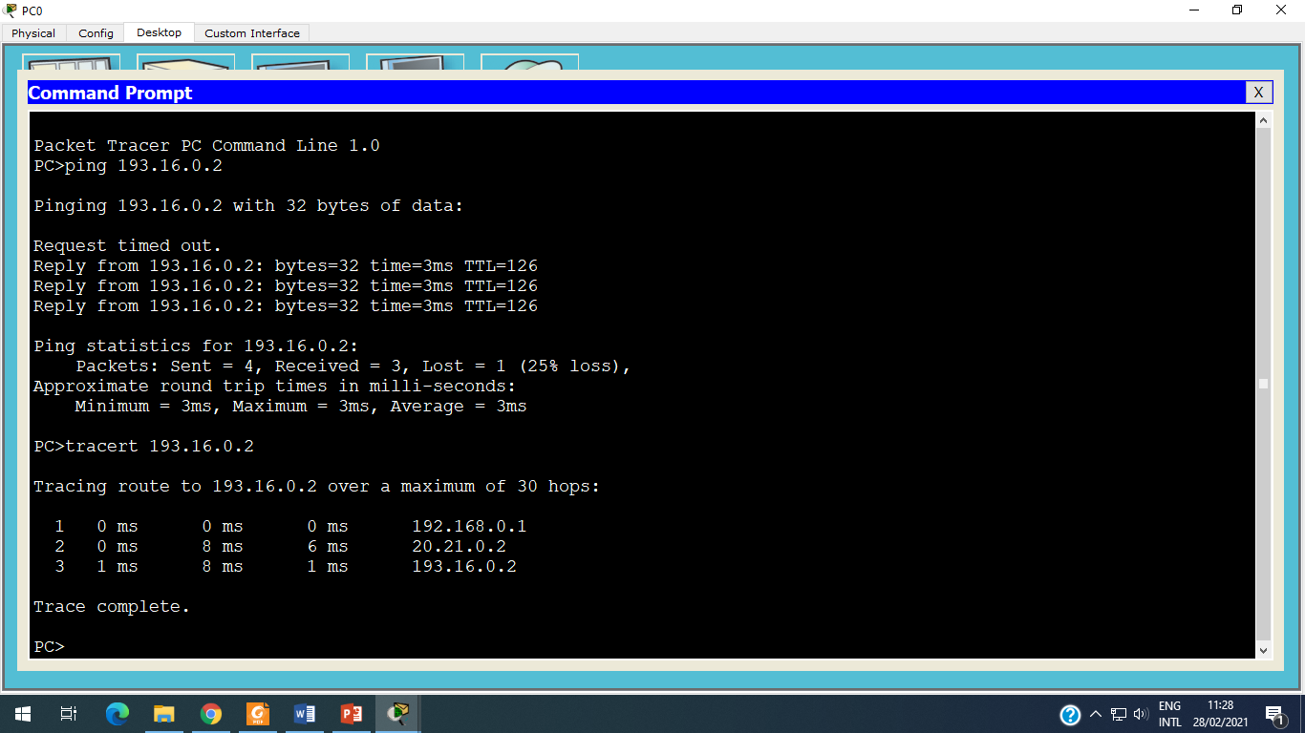

PC0 to PC2

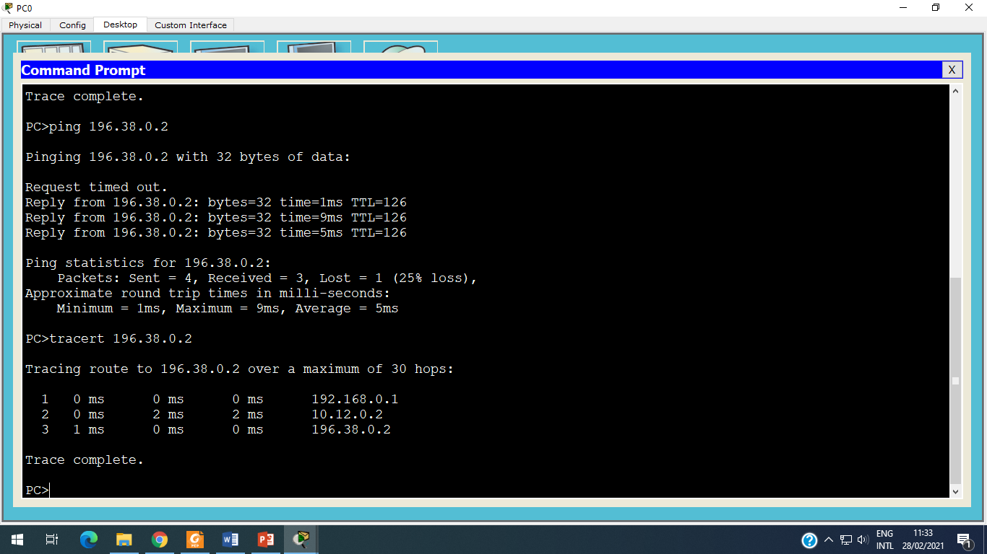

PC0 to PC3

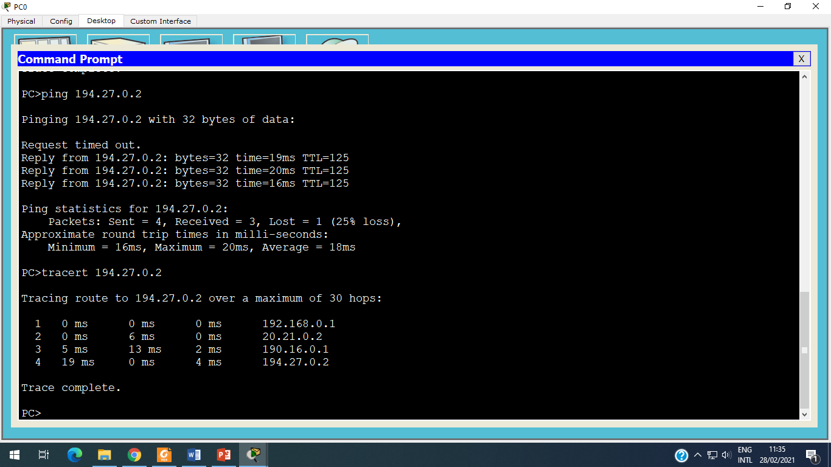

**Step 12:** Similarly like step 11, ping and tracert from PC1 to PC0, PC2, PC3, PC2 to PC0, PC1, PC3, and PC3 to PC0, PC1, PC2.

**Step 13:** Down (Remove) the link between Router 0 to Router 2.

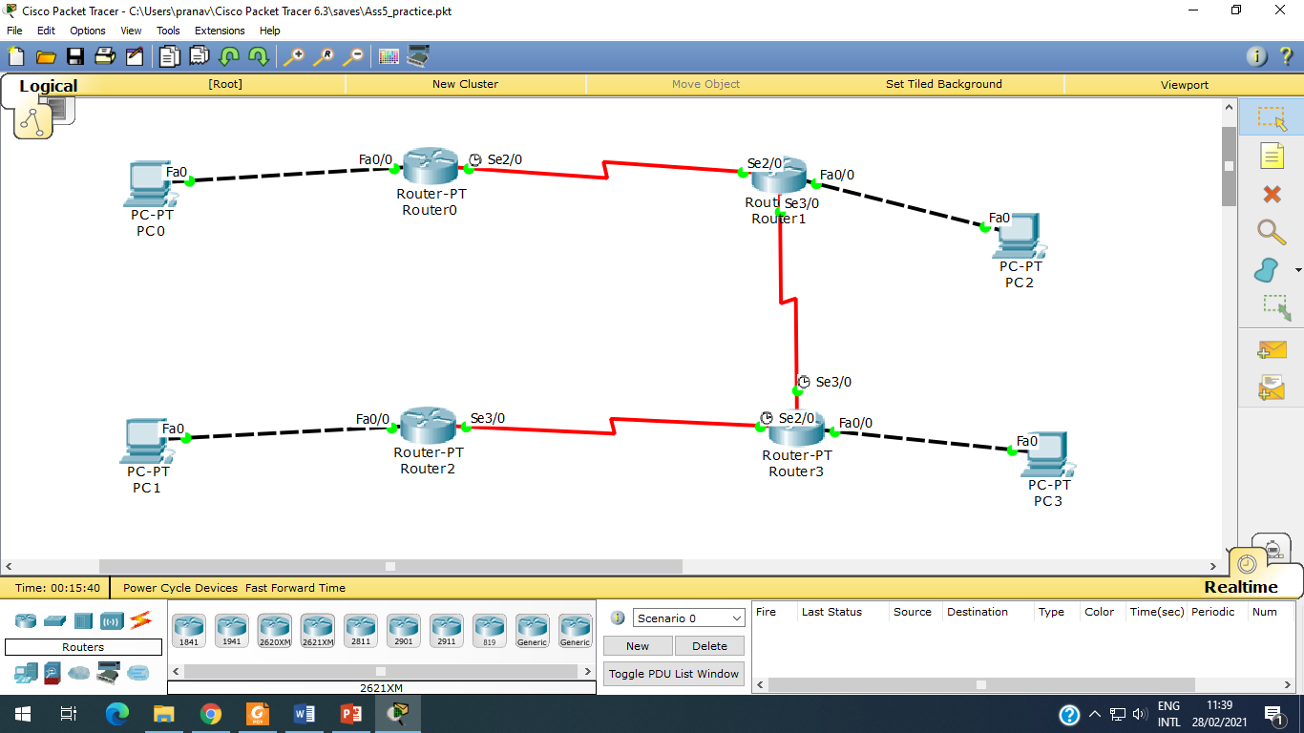

**Step 14:** Ping and tracert from PC0 to PC1, and observe the difference.

